**PUSL2010 Technology Justification**

**RANUL**

**Cloud Computing**

Today productivity and innovation in a business is a key, few years back cloud computing was an emerging technology but today, it’s being used by airlines, banks, IT companies and almost anywhere we see people use these cloud services from secured online meetings and transactions to personal movie entertainment. Today users are interacting with the cloud than ever before in fact statistics at the time writing show the data usage in a second is nearly 100,000 gigabytes that are made to the cloud. (Our World in Data, 2017)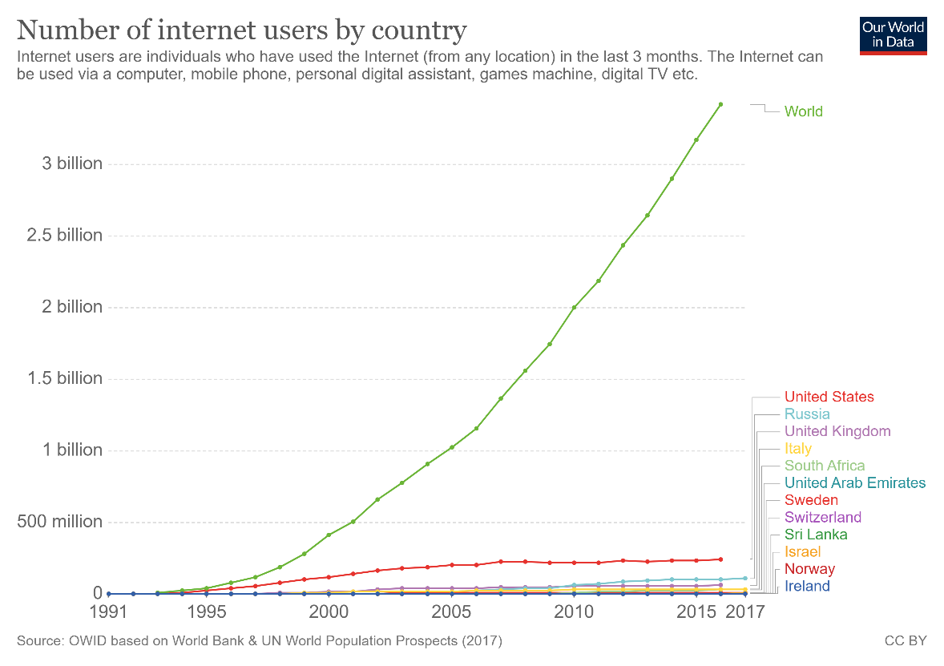

Figure : Graph of Number of Internet User (Our World in Data, 2017)

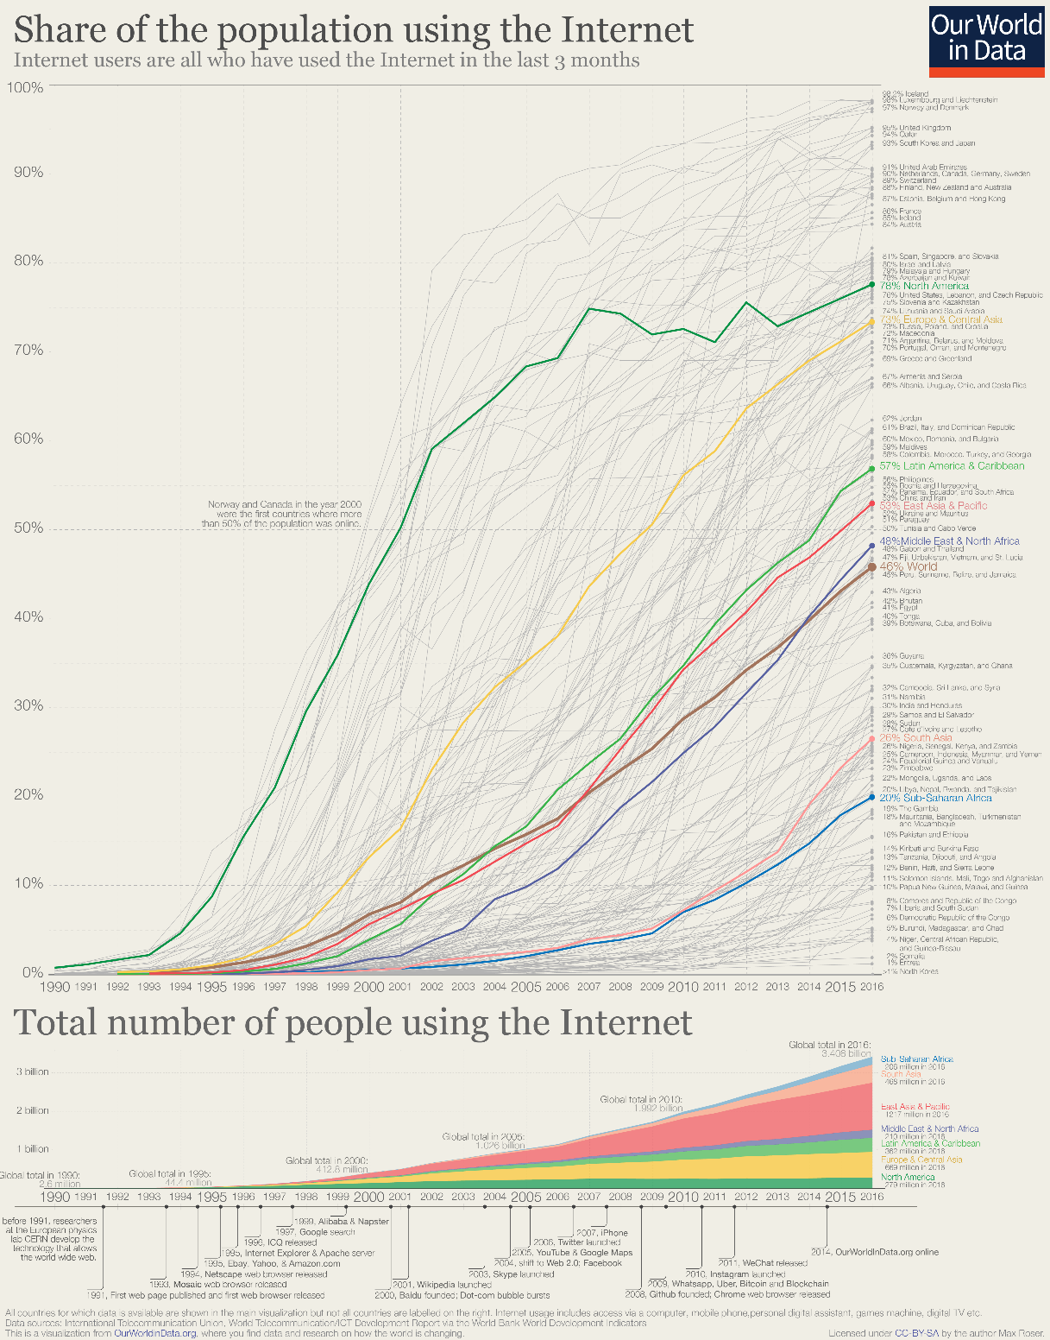

Figure : Figure 1: Graph of Number of Internet User in the World (Our World in Data, 2017)

**Types of cloud computing**

There are three types of services on a public cloud, private cloud or hybrid cloud.

**Public cloud**

Public clouds are provided by third party vendors to clients they offer these services usually for free or exceptionally low costs, all the software and hardware are managed by the vender and they allow client to access these resources over the internet virtually.

**Private cloud**

A private cloud usually is stored on a company’s premises for their business use only, this is comparatively costly compared to the method where vendors host the data on their private cloud offsite for low cost as they can virtualize and share resources.

**Hybrid cloud**

Hybrid clouds combine public and private clouds allowing much flexibility for access content within the private and public clouds, this allows a working officer to use the company’s public website to login securely to companies’ private resources with properly authentication. Most business use the hybrid cloud technology today.

**Types of Cloud Services**

**Infrastructure as a service (IaaS)**

IT infrastructure which includes servers, storage and other hardware are provide for a rental which make this a good choice for most entrepreneurs. i.e. AWS, Microsoft Azure

**Platform as a service (PaaS)**

Platform as a service offers the required hardware and software to be accessed online, similar IaaS but offer more flexibility on selecting a separate operating system and other hardware as platform for software without high level server management. i.e. Google App Engine

**Software as a service (SaaS)**

Software as a service allows users to access and use application using a web browser or similar tool by loading only required assets to the client end, this allows much flexibility and content can be access from any device that has web browsing. i.e. Office 365 Online, Jira, Github

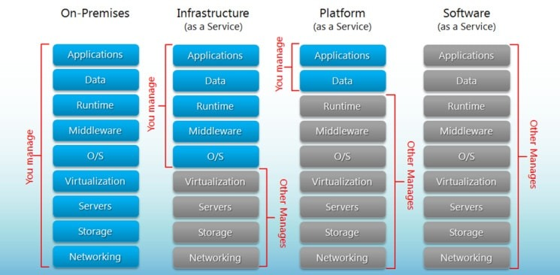

Figure :Comparison Illustration of Iaas, PaaS and SaaS (BigCommerce, 2020)

Advantages

* Cost Efficiency – Compared to traditional method implementation, maintenance and upgrading cost are exceptionally low. New cloud-based systems are very economical for both startups and large enterprises.
* Backup and Recovery – Data available on cloud allows to quickly restore data and failure rate is low as there are multiple servers to save copies of the same data.
* Storage – Cloud storage allows users to expand storage at very low costs compared to on premises storage disks, it saves costs on expanding building size for storage requirements and economical.
* Speed – Most services provide edge speeds with cloud storage, when they use SSDs but to be benefited by this technology customer should have an internet connection with a good bandwidth of at least 10MBps.
* Global Scale – Cloud systems are assessible from anywhere without extra costs and allows to integrate and work with multinationals with ease, in fact cloud services make little impact on client’s storage, processing power and bandwidth.
* Security – Most issuers supply a satisfactory level of privacy configuration and controls for management and connections are secured using network encryption and storage encryption.
* Performance and Reliability – Datacenters upgrade their components regularly which offers users the best in class experience with their service. With new implementation plans there is less downtimes and slow down as data is accessible from multiple datacenters around the globe.
* Productivity – Deployment of services could be done within few hours compared to on premises storage that usually take weeks to get configured in most cases.

Disadvantages

* Security – There’s considerable risk of data theft when selecting cloud storage as the IT infrastructure of a business in the past, confidential data and financial records have been compromised.
* Network – In order to be benefited clients need have an active network connection and an above average bandwidth to keep a constant connection with the service.
* Technical – There can issues as servers are prone to DDoS attacks and suffer downtime, sometimes even cloud services suffer from internet and power issues which effects client’s business as they have limited functionalities to manage the cloud.
* Vendor Lock-in – Migrating from on cloud service to another is not flexible but new services are being built to mitigate these limitations such as cluster sharing that are provided by SQL Server.
* Support – Communications between the cloud provider and client takes time usually emails take 2 working days or weeks for a response on busy weeks this isn’t acceptable for most businesses.

Cloud computing offers both advantages and risks to a business if not properly implemented, considering all facts it would be better to store highly confidential static data on premises and other data on the cloud which requires regular interactions.

**LAHIRU**

**NIDULA**

**Traditional server deployment**

The Advantages

* High Performance- Since all the recourse are dedicated and it can handle high stress scenarios.
* Easy to identify problems – It is easy to identify the problem and only one server will fail at a time.
* Easy to use- Since this technology has lasted for a long time there is a small learning curve for the IT department.

The Disadvantages

* Price- The equipment cost will increase over time because more application is equal to more servers and gradually there will be a huge amount of cost for hardware.
* Lack of growth and consistency- Since in order to grow we need add more servers and to do this physical space is needed and management of servers can be difficult, so it lacks growth and is inconsistent.

**Virtualized deployment**

“Server virtualization is the process of using software on a physical server to create multiple partitions or "virtual instances" each capable of running independently”. And we must clearly understand the benefits and disadvantages of using this deployment rather than the other options we could choose from. we could use this deployment if we are planning to reduce the application downtime and simplify backup process or Use more applications and OS without breaking budgets for hardware, electricity, and space and there are more scenarios where this deployment would be preferred so when choosing we must ensure it satisfies our business requirement. In addition, in server virtualization there are three types of server virtualization and they are **Virtual machine model, Paravirtual machine and OS-level. So, choosing the type of virtualization of server is also important because it can affect the business.**

The Advantages

* **Reduced Hardware Costs- Since there are fewer physical servers this will reduce the initial hardware cost that is required for the equipment.**
* **Growth and Scalability - Since it is running a physical server if we upgrade it then all the virtual instances will also get, and upgrade and another good thing is that less hardware complications and the main thing is it is easy to grow.**
* **Energy Cost Savings- Since there is fewer physical servers this will reduce the energy cost at a huge rate.**
* **Simplified backup and recovery – Virtualized servers are easy to recover data because the virtualization software’s has a feature for back up and recovery. This may be from cyber attack to natural disaster still the data can be recovered.**
* **Security – A virtualized environment makes it easier to manage the security of the server.**

The disadvantages

* **High cost for initial setup – Even though overall cost is reduced there is a high cost for initial setup since there is licensing and more.**
* It’s not Easy – There is a big learning curve since there are many different types of architectures and different types of software.
* Slow performance – There is a slow performance because of all the stress is on a single machine which my result I longer processing times and finally there are network bottleneck.

**In housed deployment**

In house server are the server that are installed within the premises of the organization

Advantages

* Keeps critical data in-house - Since all the data is within the premises no third party will have the information that is stored, and we have total control of the data
* No need to rely on an Internet connection – The business do not need to rely on the internet to access the data this may be rally helpful if the business is located in a low connection area.
* Can be more cost-effective for small to mid-sized companies- We do not have to pay a monthly fee like for the cloud and since we have control, we can upgrade the server to meet our business requirements along the line

Disadvantages

* Requires a capital investment – A large amount of capital investment is required for the hardware equipment and the infrastructure and this is one of the main disadvantages.
* Needs space – This type of deployment needs space for the servers and more space may be required if we plan to add more racks in the future in addition needs a dedicated IT staff to handle this equipment and make sure everything is working fine
* May be more susceptible to data loss during disaster – The reason is if the business is in an area where natural disasters are common then have an inhouse servers in not a good idea because there is a higher chance of data loss due to these disasters.
* No uptime or recovery time guarantees – Since we take full responsibility, we cannot guarantee a recovery time like data centers.

**Offsite Server deployment**

It is when the company’s data is stored of the premises of the organization in a data center.

Advantages

* Reduce Cost – Storing data in a data center lower the expenses because all the hardware cost, maintenance and energy cost is reduced.
* More Space- We have more space for other things because all the server space is no longer needed for the servers.

Disadvantages

* The main draw back of offsite is that we do not know enough of the data center and it is important that we decide carefully and do some research on them and ensure they have a good record because we will be trusting them with our data.

**RYAN**

**ISHAN**

**Bibliography**

[Apostu, A. (2013) 'Study on advantages and disadvantages of Cloud Computing – the advantages of Telemetry Applications in the Cloud', *Recent Advances in Applied Computer Science and Digital Services*, Economic Informatics and Cybernetics Department Academy of Economic Studies 15-17, Calea DorobanŃi, Bucharest 4, University POLITEHNICA of Bucharest ROMANIA.](https://pdfs.semanticscholar.org/ada5/876e216130cdd7ad6e44539849049dd2de39.pdf)

**References**

https://sysgen.ca/cloud-vs-in-house-servers/

http://techgenix.com/pros-cons-server-virtualization/

Hou, T. (2020) 'IaaS vs PaaS vs SaaS Enter the Ecommerce Vernacular: What You Need to Know, Examples & More', *BIGCOMMERCE*, 9 April. Available at: <https://www.bigcommerce.com/blog/saas-vs-paas-vs-iaas/#the-key-differences-between-on-premise-saas-paas-iaas> (Accessed: 09 April 2020).

Our World in Data (2017) *Internet*. Available at: <https://ourworldindata.org/internet>

 (Accessed: 08 April 2020).